Species identification tips and tricks
Use this simple identification guide to spot all the different species living in your local area- you might be surprised at just how many there are. All of these species are important because they look after our ecosystems in different ways, so we need to protect all of them to keep our environment healthy and happy!

Bumblebees
These pollinators are very round and very hairy, so they look fluffy and are easy to recognise. Each different type of Bumblebee has a different coloured tail.
- White-tailed bumblebee

- Red-tailed bumblebee

- Ginger-yellow bumblebee

Honeybees
These bees are less hairy than bumblebees, and usually have a bend in their antennae. They love lavender and sunflowers and if you look closely, you can often see pollen balls on their front legs.

Hairy-footed flower bees
These bees are very hairy and quite round but are different to bumblebees because they do not have stripes. The males have all ginger bodies and a hairy face. The females are all-black with orange hairs around their back legs.
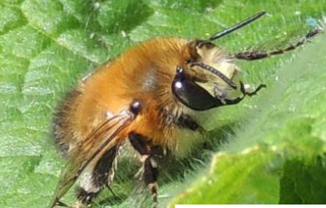
- Male hairy-footed flower bee

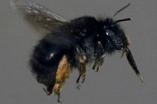
- Female hairy-footed flower bee

Wasps
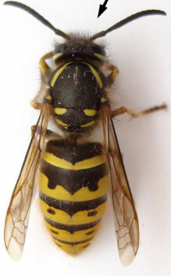
People often mistake bees for wasps, but there are some easy ways to tell the two apart. Wasps are much less hairy and have a “waist”. Wasps are important pollinators too, and we would not have figs if we did not have wasps.
- Wasp

Hoverflies
These look very similar to wasps, but they do not have a “waist”. They have bigger eyes which cover most of their head and shorter antennae. They are also usually shiny. Some hoverfly species look completely different to wasps.
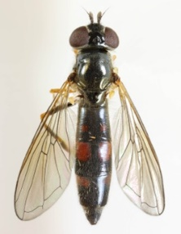
- Two different species of hoverflies
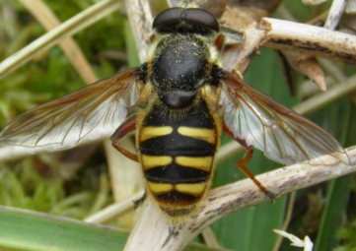

Common Garden Butterflies
Butterflies are also pollinators because they transfer pollen from one plant to another as they drink the sweet nectar inside flowers. There are lots of different butterfly species that you can spot around the United Kingdom (UK) at different times of the year. Lots of species have the same colours, but they have different patterns so you can tell them apart. You can also use the free app ‘Leps by Fieldguide’ to identify butterflies. Below are just a few examples of the butterflies you can find in the UK.
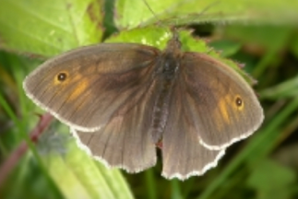
- Meadow Brown butterfly. Found June to September. These butterflies like grasslands.

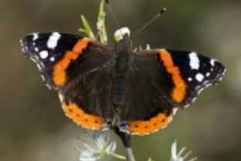
- Red Admiral butterfly. Found all year round. These butterflies like buddleia.

- Common Blue butterfly. Found May to October. These butterflies like grassy habitats.

Moths
People always think that moths are only active at night and that they are boring brown colours, but lots of them are actually very pretty and can be seen flying around during the day. Nocturnal species can also be seen during the day as they sleep on bushes, trees, walls and fences near lights. You can also use the free app ‘Leps by Fieldguide’ to identify moth species. Below are just a few examples of the moths you can find in the UK.
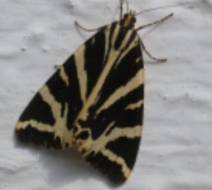
- Jersey Tiger. A daytime moth, found July to September, common in South England.

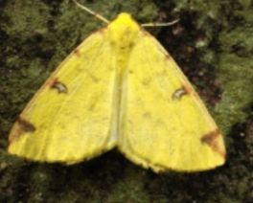
- Brimstone. A nocturnal moth, found April to October. Seen on plants in daytime and attracted to light at night.

Garden birds
These beautiful species will visit your garden, and often use bird feeders or bird baths. You can use the free app ‘Bird Net’ to identify bird song or use the free app ‘Merlin’ to identify birds by size, colour and habitat. These species are normally out and about when the sun is shining.
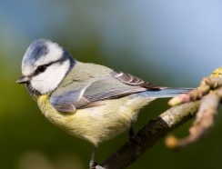
- Blue tit. Very small, seen all year in parks, woodlands and gardens, eats peanuts from bird feeders.

- Long-tailed tit. Long black tail, seen all year in gardens and woodlands, likes bushes.

- Goldfinch. Red face, brown body, seen all year in gardens parks and woodlands, eats dandelion seeds.

- Chaffinch. Seen all year in gardens, parks and woodlands, hops on the ground under bird feeders.

- Starling. Purple, green and black, Seen all year in gardens, towns and woodlands. Makes a clicking sound, eats insects and fruit.

- Song thrush. White belly with black raindrop-shaped spots, seen all year in gardens and woodlands.

- Great tit. Larger than blue tit, black head and black stripe on yellow belly. Seen all year in parks, woodlands and gardens.

- Coal tit. White patch on black head, seen all year in gardens and woodlands. Eats insects.

- Greenfinch. Green, yellow on wings. Seen all year in gardens farms and woodlands, eats seeds.

- Bullfinch. Seen all year in gardens, and hedgerows. Likes sunflower seeds. Females have brown, not pink colours.

- Blackbird. Seen all year in gardens, towns and parks. Eats worms and berries. Females are light brown.

